1. 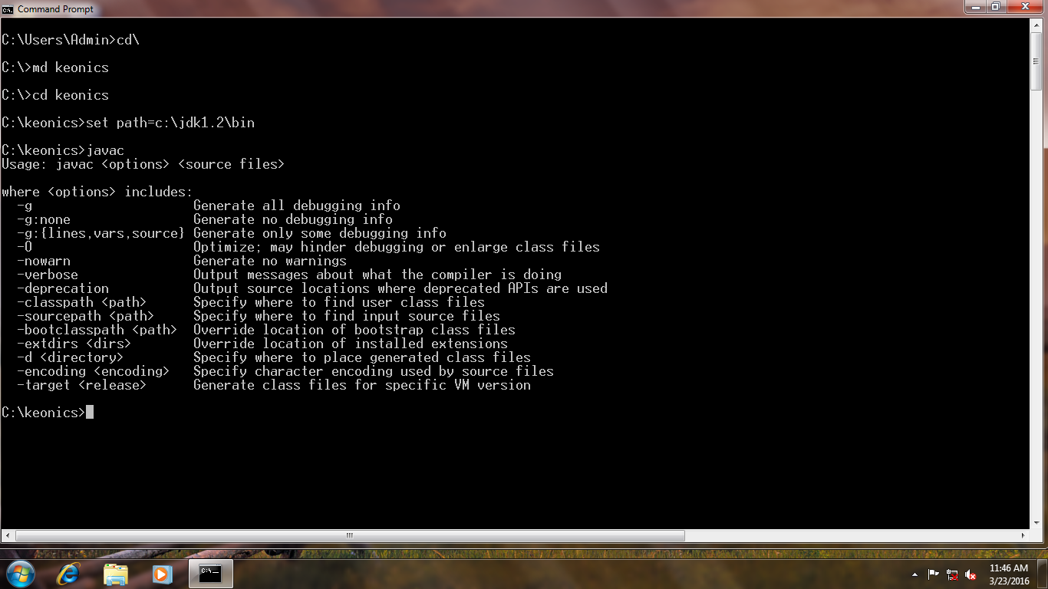Print Simple message.

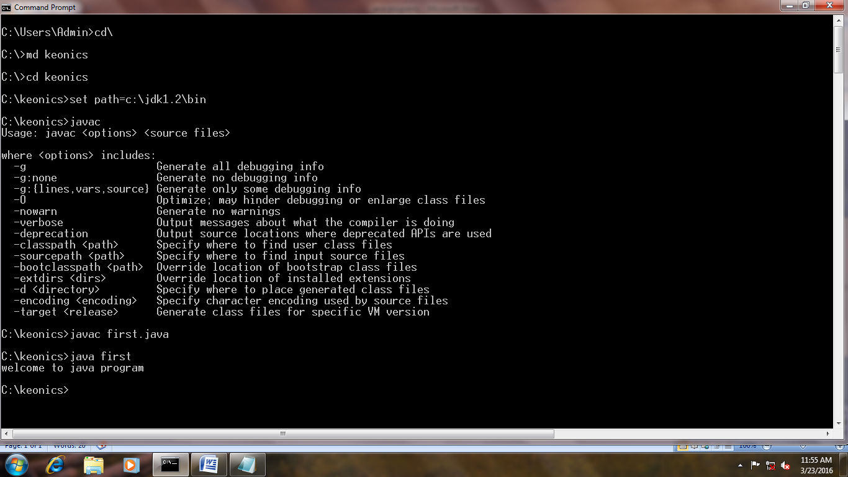Class first

{

Public static void main (String args [ ])

{

System.out.println ("welcome to java program");

}

}

1. /\* wap to print simple message.\*/

Class bio

{

Public static void main (String args [ ])

{

System.out.println (“\*\*\*\*\*\*\*\*\*\*\*\*BIODATA\*\*\*\*\*\*\*\*\*\*\*\*" );

System.out.println (" NAME : ABC " );

System.out.println (" ADDRESS : XYZ " );

System.out.println (" DOB : 29-MAR-16 " );

System.out.println (“\*\*\*\*\*\*\*\*\*\*\*\*\*\*END\*\*\*\*\*\*\*\*\*\*\*\*" );

}

}

1. /\*//wap to find sum and average of two no's.\*/

Class sum

{

Public static void main (String args [])

{

Int a=5, b=4;

Double sum=0, avg=0;

Sum=a+b;

Avg=sum/2;

System.out.println (“sum=“+sum);

System.out.println (“average=“+avg);

}

}

1. /\*//wap to find simple interest \*/

Class simple

{

Public static void main (String args [])

{

Int p=5000, t=2;

Double r=3.5, si=0;

Si= (p\*t\*r)/100;

System.out.println (“simple interest=“+si);

}

}

1. /\*//wap to find area and perimeter of square. \*/

Class area

{

Public static void main (String args [])

{

Int a=5;

Double area=0, peri=0;

Area=a\*a;

Peri=4\*a;

System.out.println (“area=“+area);

System.out.println (“perimeter=“+peri);

}

}

1. /\*//wap to find area and perimeter of rectangle. \*/

Class rect

{

Public static void main (String args [])

{

Int l=5, w=4;

Double area=0, peri=0;

Area=l\*w;

Peri=2\*(l+w);

System.out.println (“area=“+area);

System.out.println (“perimeter=“+peri);

}

}

1. /\* wap to find maximum no's\*/

Class max

{

Public static void main (String args [])

{

Int a=4, b=5, max;

If (a>b)

System.out.println (" a is maximum”);

Else

System.out.println (" b is maximum”);

}

}

1. /\* wap to find even or odd no's\*/

Class even

{

Public static void main (String args [])

{

Int a=5;

If (a%2==0)

System.out.println (" a is even" );

Else

System.out.println (" a is odd”);

}

}

1. /\* wap to find +ve and -ve no's\*/

Class nums

{

Public static void main (String args [])

{

Int a=-5;

If (a>0)

System.out.println (" no is +ve" );

Else

System.out.println (" no is -ve”);

}

}

1. //program to find sum and average of two no's.

Import java.io.\*;

Class avg

{

Public static void main (String args []) throws IOException

{

BufferedReader stdin=new BufferedReader (new InputStreamReader (System.in));

Double a, b, sum=0, avg=0;

System.out.println (" enter the value of a:" );

a=Double.parseDouble (stdin.readLine ( ));

System.out.println (" enter the value of b:" );

b=Double.parseDouble (stdin.readLine ( ));

Sum=a+b;

Avg=sum/2;

System.out.println (" sum: =" +sum);

System.out.println (" average: =" +avg);

}

}

1. /\* wap to find simple interest.\*/

Import java.io.\*;

Class si

{

Public static void main (String args []) throws IOException

{

BufferedReader stdin=new BufferedReader (new

InputStreamReader (System.in));

Double p, t, r, si=0;

System.out.print ("Enter the value of Principalamount :");

p=Double.parseDouble (stdin.readLine ());

System.out.print ("Enter the value of Time :");

t=Double.parseDouble (stdin.readLine ());

System.out.print ("Enter the value of Rate :");

r=Double.parseDouble (stdin.readLine ());

Si= (p\*t\*r)/100;

System.out.println ("simple interest: ="+si);

}

}

1. /\* wap to find area and perimeter of square.\*/

Import java.io.\*;

Class ar

{

Public static void main (String args []) throws IOException

{

BufferedReader stdin=new BufferedReader (new

InputStreamReader (System.in));

Int a, area=0, peri=0;

System.out.print ("Enter the value of a :");

a=Integer.parseInt (stdin.readLine ());

Area=a\*a;

Peri=4\*a;

System.out.println ("area: ="+area);

System.out.println ("perimeter: ="+peri);

}

}

1. /\* wap to find area and perimeter of rectangle.\*/

Import java.io.\*;

Class rect

{

Public static void main (String args []) throws IOException

{

BufferedReader stdin=new BufferedReader (new

InputStreamReader (System.in));

Int l, w, area=0, peri=0;

System.out.print ("Enter the value of l :");

l=Integer.parseInt (stdin.readLine ());

System.out.print ("Enter the value of w :");

w=Integer.parseInt (stdin.readLine ());

Area=l\*w;

Peri=2\*(l+w);

System.out.println ("area: ="+area);

System.out.println ("perimeter: ="+peri);

}

}

1. /\* wap to find even or odd no's.\*/

Import java.io.\*;

Class odd

{

Public static void main (String args []) throws IOException

{

BufferedReader stdin=new BufferedReader

(NewInputStreamReader (System.in));

Inta, even=0, odd=0;

System.out.println ("enter the value of a :");

a=Integer.parseInt (stdin.readLine ());

If (a%2==0)

System.out.println ("a is even");

Else

System.out.println ("a is odd");

}

}

1. /\* wap to find maximum of two no's.\*/

Import java.io.\*;

Class max

{

Public static void main (String args []) throws IOException

{

BufferedReader stdin=new BufferedReader

(NewInputStreamReader (System.in));

Int a, b, max=0;

System.out.println ("enter the value of a :");

a=Integer.parseInt (stdin.readLine ());

System.out.println ("enter the value of b :");

b=Integer.parseInt (stdin.readLine ());

If (a>b)

System.out.println ("a is maximum");

Else

System.out.println ("b is maximum");

}

}

1. /\* wap to find +ve and -ve numbers.\*/

Import java.io.\*;

Class nos

{

Public static void main (String args []) throws IOException

{

BufferedReader stdin=new BufferedReader (new

InputStreamReader (System.in));

Int a;

System.out.print ("enter the value of a :");

a=Integer.parseInt (stdin.readLine ());

If (a>0)

System.out.println ("number is +ve");

Else

System.out.println ("number is -ve");

}

}

1. /\* wap to demonstrate student marks sheet.\*/

Import java.io.\*;

Class student

{

Public static void main (String args []) throws IOException

{

BufferedReader stdin=new BufferedReader (new

InputStreamReader (System.in));

Int rollno, STD, Kan, eng, hin, total=0;

Double per=0;

String name;

System.out.print ("enter the student name :");

Name=stdin.readLine ();

System.out.print ("enter the student rollno :");

Rollno=Integer.parseInt (stdin.readLine ());

System.out.print ("enter the slandered :");

STD=Integer.parseInt (stdin.readLine ());

System.out.print ("enter the subject Kannada :");

Kan=Integer.parseInt (stdin.readLine ());

System.out.print ("enter the subject English :");

Eng=Integer.parseInt (stdin.readLine ());

System.out.print ("enter the subject Hindi :");

Hin=Integer.parseInt (stdin.readLine ());

{

Total=Kan+eng+hin;

Per=total/3;

}

System.out.println ("\*\*\*\*\*\*\*\*\*\*student marks detail\*\*\*\*\*\*\*\*\*\*\*");

System.out.println ("Student Name: ="+name);

System.out.println ("Student Rollno: ="+rollno);

System.out.println ("Total Marks: ="+total);

System.out.println ("Percentage: ="+per);

System.out.println ("\*\*\*\*\*\*\*\*\*\*End of detail\*\*\*\*\*\*\*\*\*\*\*");

}

}

1. /\* wap to demonstrate employee detail.\*/

Import java.io.\*;

Class employee

{

Public static void main (String args []) throws IOException

{

BufferedReader stdin=new BufferedReader (new

InputStreamReader (System.in));

Int code;

Double basic, hra, da, gross, pf, ns;

String name;

System.out.print ("enter the employee name :");

Name=stdin.readLine ();

System.out.print ("enter the code :");

Code=Integer.parseInt (stdin.readLine ());

System.out.print ("enter the basic :");

Basic=Integer.parseInt (stdin.readLine ());

{

Hra=basic\*0.03;

Da=basic\*0.02;

Gross=basic+hra+da;

Pf=basic\*0.01;

Ns=gross-pf;

}

System.out.println ("\*\*\*\*\*\*\*\*\*\*employee detail\*\*\*\*\*\*\*\*\*\*\*");

System.out.println (" Name: ="+name);

System.out.println (" code: ="+code);

System.out.println ("net salary: ="+ns);

System.out.println ("\*\*\*\*\*\*\*\*\*\*End of detail\*\*\*\*\*\*\*\*\*\*\*");

}

}

1. /\* wap to demonstrate commission of sales.\*/

Import java.io.\*;

Class sales

{

Public static void main (String args []) throws IOException

{

BufferedReader stdin=new BufferedReader (new

InputStreamReader (System.in));

Int code, qty;

Double price, amount, comm, net;

String product;

System.out.print ("enter the product :");

Product=stdin.readLine ();

System.out.print ("enter the code :");

Code=Integer.parseInt (stdin.readLine ());

System.out.print ("enter the quantity :");

Qty=Integer.parseInt (stdin.readLine ());

System.out.print ("enter the price :");

Price=Integer.parseInt (stdin.readLine ());

{

Amount=qty\*price;

Comm=amount\*0.02;

Net=amount+comm;

}

System.out.println ("\*\*\*\*\*\*\*\*\*\*sales detail\*\*\*\*\*\*\*\*\*\*\*");

System.out.println (" product: ="+product);

System.out.println (" quantity: ="+qty);

System.out.println (" price: ="+price);

System.out.println (" amount: ="+amount);

System.out.println (" commission: ="+comm);

System.out.println (" net: ="+net);

System.out.println ("\*\*\*\*\*\*\*\*\*\*End of detail\*\*\*\*\*\*\*\*\*\*\*");

}

}

1. /\* wap to demonstrate bank account detail.\*/

Import java.io.\*;

Class account

{

Public static void main (String args []) throws IOException

{

BufferedReader stdin=new BufferedReader (new

InputStreamReader (System.in));

Int accno;

Double BAL, interest, amount;

String accname;

System.out.print ("enter the account name :");

Accname=stdin.readLine ();

System.out.print ("enter the account number :");

Accno=Integer.parseInt (stdin.readLine ());

System.out.print ("enter the balance :");

BAL=Integer.parseInt (stdin.readLine ());

{

Interest=BAL\*0.03;

Amount=BAL+interest;

}

System.out.println ("\*\*\*\*\*\*\*\*\*\*bank account detail\*\*\*\*\*\*\*\*\*\*\*");

System.out.println (" account Name: ="+accname);

System.out.println (" account number: ="+accno);

System.out.println (" balance: ="+BAL);

System.out.println ("interest: ="+interest);

System.out.println ("total amount: ="+amount);

System.out.println ("\*\*\*\*\*\*\*\*\*\*End of detail\*\*\*\*\*\*\*\*\*\*\*");

}

}